ASEAN Must Not Ignore Human Rights Issues in the Region

Jakarta, 11 July 2023. "ASEAN must not ignore human rights issues. Our differences should not be an excuse for us to abandon pressing human rights issue in our own region." This statement was conveyed by Foreign Minister Retno Marsudi during the ASEAN Intergovernmental Commission on Human Rights (AICHR) meeting on Tuesday (11/7) in Jakarta.

Minister Retno stated that in the context of advancing human rights, ASEAN must continue to nurture cooperation based on goodwill and willingness to learn from each other. In this regard, Minister Retno highlighted two areas of ASEAN's cooperation in the field of human rights.

Firstly, the need to nurture a tradition of dialogue. According to Minister Retno, amidst various differences, ASEAN must continue to prioritize dialogue to safeguard progress in the field of human rights. One example is through the ASEAN Human Rights Dialogue. This forum demonstrates that ASEAN member states can engage in honest and open dialogues to address human rights issues in the region.

"It is important for this forum to be conducted regularly. Therefore, we hope that the Leaders' Declaration on ASEAN Human Rights Dialogue can be achieved," said Minister Retno.

Secondly, there is a need to project ASEAN values at global level. In this regard, Minister Retno stated that the global crisis and rivalries have exacerbated the challenges in advancing human rights globally. She encouraged ASEAN to lead by example by prioritizing constructive engagements over finger-pointing exercises.

Furthermore, Minister Retno emphasized the need for ASEAN countries to reject double standards and the politicization of human rights issues. Regarding this matter, Minister Retno urged ASEAN to remain committed to push for the resolution of various human rights issues in the region.

Regarding the enhancement of AICHR's role, Minister Retno expressed her hope that AICHR's programs would not be limited to capacity-building alone but could also include other initiatives with tangible impacts.

During this meeting between Foreign Ministers and AICHR Representatives, the situation in Myanmar still dominated the discussions. Apart from the Myanmar situation, the meeting also addressed the issue of trafficking in persons as well as the impact of climate change on human rights. Further, AICHR Representatives highlighted concerns about the escalation of violence and the lack of progress in the implementation of the Five-Point Consensus (5PC).

Concluding the meeting, Minister Retno emphasized that AICHR must continue to promote human rights values that are appropriate within the regional context. AICHR also needs to consistently advocate for constructive, objective, and proportionate promotion and protection of human rights in the three pillars of the ASEAN Community, in line with the Five-Year Work Plan 2021-2025. On the implementation of the 5PC, Minister Retno stated that this issue would be discussed at the AMM Retreat.

***

For further information, please contact the following:

Director for Information and Media of the Ministry of Foreign Affairs - Hartyo Harkomoyo (+62811831899).

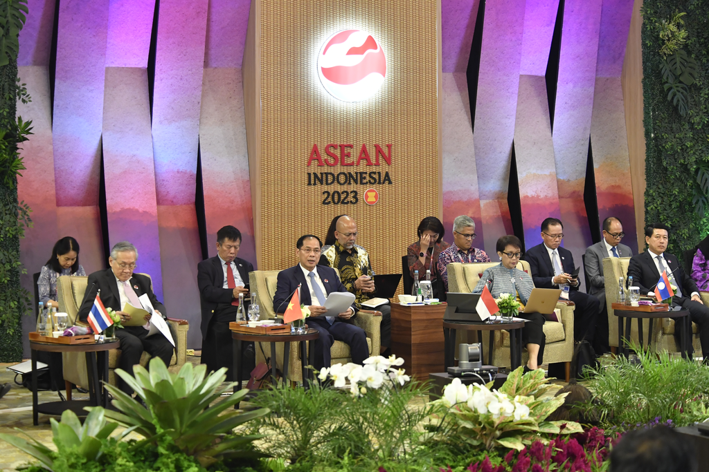

Minister Retno urged ASEAN to remain committed to push for the resolution of various human rights issues in the region during the ASEAN Intergovernmental Commission on Human Rights (AICHR) meeting on Tuesday (11/7) in Jakarta (Photo: Ministry of Foreign Affairs of Indonesia).

